

01OAIQD – Dynamic Design of Machines

Academic year 2015-2016

THEORY EXERCISES ON FE DYNAMICS AND ROTORDYNAMICS: choose the correct answer. Briefly explain in few lines, eventually resorting to graphs, schemes or formulas, the reason of your choice and exclusion of the other possible answers.

- If the shear deformation is considered in the study of the vibration motion of a beam,
  - all the natural frequencies of the model increases,
  - all the natural frequencies of the model decreses,
  - a negligible effect on the natural frequencies if the beam is not slender enough.

- In absence of damping, the bending natural frequencies of a rotor:
  - Depend on the spin speed only in presence of gyroscopic effect
  - Depend on the spin speed only in absence of gyroscopic effect
  - Always depend on the spin speed

- If the spin speed of an undamped rotor is equal to its critical speed
  - The amplitude of the orbit grows linearly with time
  - The amplitude of the orbit grows exponentially with time
  - The amplitude of the orbit grows squarely with time

- If the spin speed of a rotor falls in a field of instability
  - The amplitude of the orbit grows linearly with time
  - The amplitude of the orbit grows exponentially with time
  - The amplitude of the orbit grows squarely with time

- To increase the threshold of instability of a rotor it is possible
  - To reduce unbalance
  - To increase the rotating damping and decrease non rotating damping
  - To increase non rotating damping and decrease rotating damping

- In general, the vibrating motion of a Jeffcott rotor is constituted
  - Of the sum of two forward and one backward whirl
  - Of the sum of two forward whirls
  - Of the sum of one forward and one backward whirl

- The self-centering can be verified
  - In subcritical region
  - In supercritical region
  - In sub- or supercritical fields, depending on the value of rotating damping.

- In case of a rotor where Jp < Jt
  - There are two critical speeds
  - There is only one critical speed
  - There are no critical speeds

- In the four degrees of freedom model for the free vibration of an undamped rotor
  - There are four values of λ (two positive and two negative) equal to pairs in modulus for each value of ω
  - There are four values of λ (two positive and two negative) different in modulus for each value of ω
  - There are four values of λ (two positive and two negative) equal to pairs in modulus for ω = 0 and different in modulus for ω > 0

- The inversion of the direction of whirling in the unbalance response of a rotor
  - Happens in the case of anisotropy of the stator, for spin speeds between the two critical speeds
  - Happens in case of anisotropy of the rotor, for spin speeds between the two critical speeds
  - Happens in case of anisotropy of the stator, for spin speeds above the second critical speed

- The presence of a field of instability between the two critical speeds can happen
  - In case of a rotor on anisotropic supports
  - In case of an anisotropic rotor, and the rotating damping tends to reduce it
  - In case of an anisotropic rotor, and the rotating damping tends to amplify it

- The phenomenon known as “oil whip” happens
  - At a frequency that is equal to the rotor’s spin speed
  - At a frequency that is half the rotor’s spin speed
  - At a frequency that is practically constant (with respect to the rotor’s spin speed)

EXERCISES:

- Compute the natural frequencies and the corresponding mode shapes of the systems presented in the Figure. It is characterized by a beam with negligible inertia and a rigid body with mass m and moment of inertia J.
Data: E = 2.0⋅10⁵ N/mm², l = 0.1 m, I = 4.91⋅10⁻¹⁰ m⁴, m = 5 kg, J = 0.05 kgm^{2.}

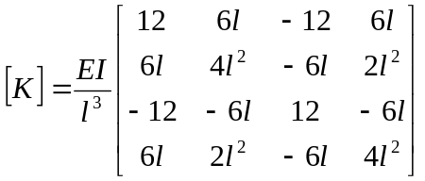
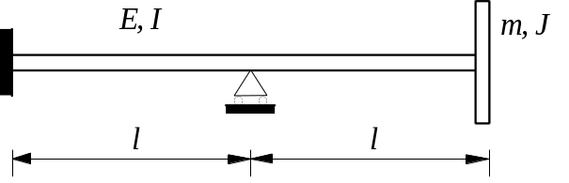

λ₁ = 106 rad/s, λ₂ = 452 rad/s.

- Calculate the first bending natural frequency of the structure shown in the figure, which is composed of a cantilever shaft (whose mass can be neglected) having a flywheel of mass m and inertia J_{t} attached to its end. Compare the results obtained studying the full system with those obtained using the Guyan reduction.
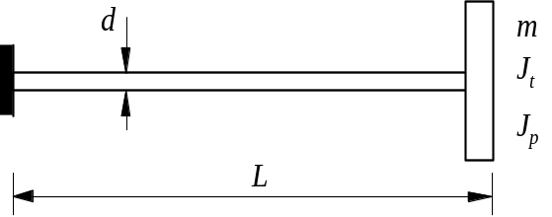
Dati: E = 2⋅1011 N/m2, ν = 0.3, L = 1 m,
d = 0.03 m, mI = 10 kg, mII = 100 kg
Jt = 1 kgm2,

The stiffness matrix of the beam element (due to the slenderness of the shaft we refer to the Euler formulation):
λ_{1I}=43.87 rad/s, λ’_{1I}=44.13 rad/s (Guyan), λ_{1II}=15.273 rad/s, λ’_{1II}=15.274 rad/s (Guyan)

- A rotor with mass m can be modeled as a Jeffcott rotor having a deformable shaft on stiff supports with distance L between the supports. The shaft has a full circular shaft with stiffness 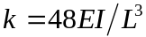 (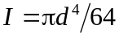). Given that the mass is fixed to the rotor with eccentricity ε and that at rated speed the radius of the orbit is equal to z₀=-1.2ε, calculate:
  - The critical speed ωcr;
  - The diameter of the shaft d;
  - The maximum bending stress on the shaft and the reactions on the supports at rated speed ω.
Data: E = 2⋅1011 N/m2, L = 0.5 m, m = 15 kg, ε = 100 μm, ω = 10000 rpm.
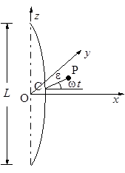
Solution:
ωcr = 427 rad/s, d = 29 mm, R = 165 N, σ = 17 MPa.
- The rotor shown in the figure is composed by a flywheel of mass m and moments of inertia J_{t} and J_{p} attached to the end of a shaft with negligible mass.
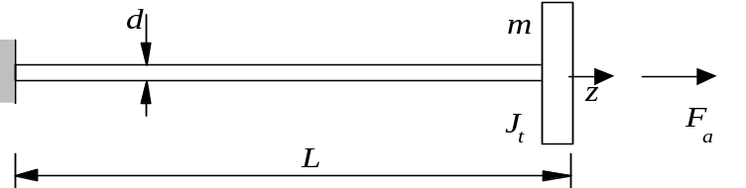
Assuming to orientate the structure vertically and to consider the effect of gravity, calculate the critical speed in the following three cases:
  - Z axis coincident with respect to the gravitational field (mass below the constraint)
  - Z axis non coinciding with gravitational field (mass above the constraint)
  - Absence of gravity (orientation is indifferent)
Data: E = 2⋅1011 N/m2, L = 0.3 m, d = 2.5 mm, m = 0.5 kg, Jt =0.0 1 kgm2 , Jp =0.0 2 kgm2
Stiffness matrix for the beam element (considering the slenderness we refer to the Euler formulation) and geometrical matrix.
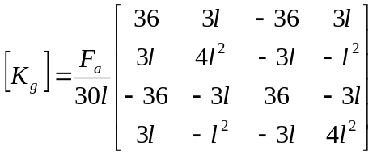
Solution:
ω_{a}=13.9 rad/s , ω_{b}=9.1 rad/s, ω_{c}=11.8 rad/s.

- A rotor with mass m can be modeled as a Jeffcott rotor having a deformable shaft on stiff supports with distance L between the supports. The shaft has a full circular shaft with stiffness ().Given that the mass is fixed to the rotor with eccentricity ε, and that the rotating damping c_{r} is null, calculate:
  - The critical speed ωcr
  - The nonrotating damping c_{n} necessary to keep the radius of the orbit z₀ below 1.25ε;
  - The radius of the orbit z₀ when crossing the critical speed assuming the value of c_{n} calculated in the previous question.
Data: E = 2⋅1011 N/m2, L = 0.5 m, d = 0.029 m, m = 15 kg, ε = 10 μm, ω = 8000 turns/min.

Solution:
ωcr = 427 rad/s, cn = 3.61⋅103 Ns/m, 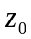 = 17.5 μm.

- A rotor with mass m can be modeled as a Jeffcott rotor having a deformable shaft with bending stiffness k. The bearings have a known viscous damping coefficient c_{n}; the relative total damping ζ = (cn + cr) / ccr is evaluated with tests. Calculate the threshold of instability of the rotor.
Data: k = 50 kN/m, m = 30 kg, ζ = 0.05, cn = 100 Ns/m.

Solution:
ωthreshold = 226 rad/s.

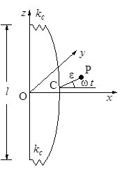
- A Jeffcott rotor is constituted by a mass m, having eccentricity ε, fixed in the middle of a deformable shaft with length l and diameter d suspended on elastic supports having stiffness k_{c}. Assuming structural rotating damping, having loss factor ηr , and viscous nonrotating damping cn , calculate:
  - The critical speed of the rotor
  - The viscous nonrotating damping c_{n} needed to guarantee stability
  - The amplitude and phase of the response to static unbalance at rated speed ω.

Data: m = 8 kg, l = 0.4 m, d = 0.015 m, ηr = 0.002, E = 2⋅10¹¹ N/m², kc = 5⋅10⁵ N/m, ε = 6 μm, ω = 150 rad/s.
Solution:
ωcr = 184 rad/s, cn = 4.05 Ns/m, z0 = 1.18⋅10⁻⁵ m, φ ≈ -0.4°.

- Using the Dunkerley formula, calculate the first bending critical speed for the system shown in the figure. For a beam on two supports, the deflection at the point of application of a load P is equal to 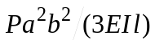, where a and b are the distances from the supports.
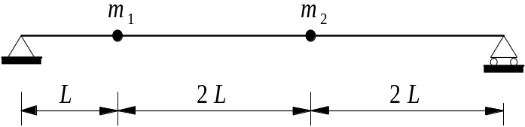

Data: E = 2⋅1011 N/m2, L = 0.125 m, d = 0.025 m, m1 = 30 kg, m2 = 50 kg.
Solution: ωcr = 114 rad/s.
- Obtain the bending critical speeds and the corresponding mode shapes for the system shown in the figure. The system represented by two beam elements using the lumped parameter approach and neglecting the distribution of the mass along the beam elements.
Data: E = 2⋅1011 N/m2, L = 0.5 m, d = 0.015 m, m = 3 kg, Jt = 0.04 kgm2, Jp = 0.08 kgm2.
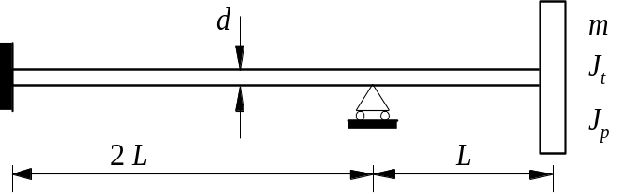
ωcr = 41.5 rad/s.
- Using the Myklestadt-Prohl method, calculate the bending critical speeds of the rotor shown in the figure, which is composed of a cantilever shaft (whose mass can be neglected) having a flywheel of mass m and inertia J_{t} , J_{p} attached to its end. Compare the results obtained considering the shear deformation with those obtained neglecting it.
Data:E = 2⋅1011 N/m2, ν = 0.3, L = 0.10 m, d = 0.03 m, m = 2 kg, Jt = 0.005 kgm2, Jp = 0.010 kgm2.
Stiffness matrix of the beam element (χ reffering to a circular cross section)
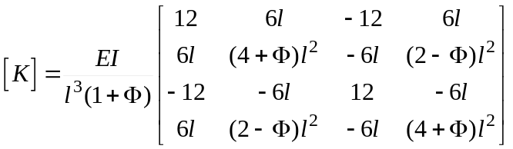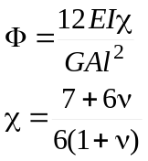
Transfer matrix for field and node.
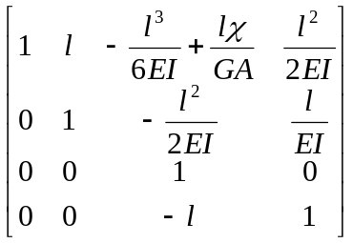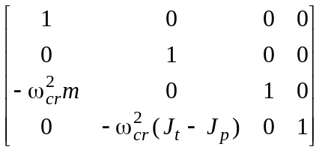
ωcr = 4.55⋅103 rad/s (shear neglected), ωcr = 4.29⋅103 rad/s (shear considered)
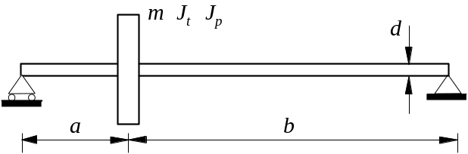
- A rotor having stiff supports, deformable shaft whose inertia can be neglected, has inertia properties m, Jt, Jp. The flywheel is attached with an eccentricity ε and angular error χ that are considered to be coplanar (α = 0). Calculate the critical speed and the amplitudo of the response due to unbalance at spin speed equal to ω.
Data: E = 2⋅1011 N/m2, a = 0.08 m, b = 0.32 m, d = 0.022 m, m = 6 kg, Jt = 1.4 kgm2, Jp = 2.6 kgm2, ε = 20 μm, χ = 0.01 rad, ω = 2000 rad/s.
ωcr = 1491 rad/s, z0,ε = -5.1·10-5 m, z0,χ = 1.0·10-3 m, φ0,ε = -1.0·10-5 rad, φ0,χ = -1.0·10-2 rad.
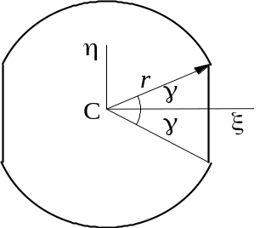
- A rotor is composed of a shaft, whose cross section is represented in the figure, on which a mass m is attached in the middle of the shaft, between the two bearings positioned at the shaft’s ends. Determine the field of instability.
Data: d = 0.040 m, l = 0.600 m, γ = 30°, E = 2⋅1011 N/m2, m = 5 kg.
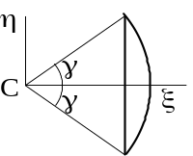
Inertia moments of the circular part
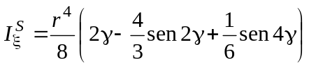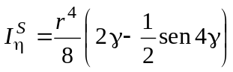
948-1051 rad/s.

